27.14b Intertestamental Period, Part B
✓ “Check” it out. An opinion, inference, supposed conversation, or fact one can verify follows.
[. . .] Brackets indicate a remark to the teacher that will not be read aloud; they also show answers to questions.
Visuals and Tools:
- Pictures and other visuals found at the end of this lesson. Check “Activities” and “Handwork” found below for additional needed materials. Please give credit to the sources of pictures.
- A time line
Bible Time Tips and Terms to Teach:
- Palestine: the name by which the land of Israel was called during Jesus’ lifetime
- Roman arch: [see page 12] a rounded opening with a keystone at the top; this design makes it possible for a structure to hold greater weight than a square opening would.
- arcade: [see page13] several Roman arches in a row
- aqueduct: arcades with troughs (ducts), usually in three levels, that carry water (aque) long distances
Introduction/Review:
Let’s have a quiz! But first we’ll review. [Teacher, as you review, use the nine half-page pictures from last week’s lesson found on pages 6–10 below. Leave these pictures on display while giving the quiz.]
In our last lesson we learned a lot of history about the time between the Old Testament and the New Testament called the Intertestamental Period or 400 Silent Years [first picture, page 6].
The Greeks wanted the whole empire to speak one language and to be of one culture—their Greek culture and language. Spreading the Greek language and culture was called Hellenization [second picture, page 6]. One good result of Hellenization was the translation of the Old Testament into the language of the people, again, Greek. This translation was called the Septuagint [first picture, page 7].
Some Jews resisted Hellenization because they wanted to remain true to the worship of their one true God. These people were called Pharisees [second picture, page 7]. Other Jews went right along with Hellenization. These were some of rich, upper-class citizens who would later control the Temple and be the priests—the Sadducees [first picture, page 8].
The Jews scattered throughout the world couldn’t get to Jerusalem, God’s appointed place of worship, so they studied the Scriptures and prayed in synagogues [second picture, page 8]. Teachers in the synagogues were called rabbis [first picture, page 9]. Men called lawyers also studied God’s law. Scribes still copied and taught the Law.
After Alexander the Great died, the land of Israel was fought over. At first, the Ptolemies ruled and allowed Jewish freedom. Then the Seleucids in the north aggressively Hellenized Israel. Antiochus Epiphanes [second picture, page 9] actually insisted the Jews worship Greek gods and sacrifice unclean animals on God’s altar in God’s Temple.
This was too much for the Maccabbee family [page 10], who led soldiers to fight from one place to another—smashing pagan altars, harassing travelers to Jerusalem, and raiding Seleucid camps—until they regained the Temple and Jerusalem for Jewish, not Hellenistic, purposes.
Now, here’s the quiz. The way you answer is to come up and find the picture that answers the question. We won’t use every picture, and we might not ask questions in the order that the pictures are displayed:
- Teachers of God’s Law were called ____________. [Accept rabbis, Pharisees, or Sadducees.]
- What was the name of the Greek translation of the Old Testament? [Septuagint.]
- What were the meeting places for worship and Bible study called? [Synagogues.]
- The time between the end of the Old Testament and the beginning of the New Testament was called ___________________________. [The Intertestamental Period or 400 Silent Years.]
- The emperor who Hellenized so much that he made the people worship Greek gods was named ___________________________. [Antiochus Epiphanes.]
- What people fought Antiochus Epiphanes and regained Temple worship? [Maccabbees.]
Story:
Rise of Rome
Our last lesson and review covered about 350 of the 400 Silent Years [show on time line]. During most of this time, the Greeks were in control. Later, however, another world power threatened the Greek empire about 200 years. That power was Rome, based in the city of Rome, Italy [locate]. By 27 b.c., after conquering vast lands, Rome became an empire, the Roman Empire, represented in Nebuchadnezzar’s image as the legs of iron—strong! Its emperors were known as Caesars; perhaps this was the greatest empire of all time.
Roman features
Several inventions and features of the Roman Empire are important to its day and to ours as well. For example, Romans invented concrete. What would we do without concrete these days? Another feature was the Roman arch, which so strengthened buildings, bridges, and aqueducts that many of those structures, built more than two thousand years ago, still survive.
Another very useful feature of the Roman Empire was its roads. Armies, messengers, traders, missionaries, and common people all used these roads. The more than 250,000 miles of roads (over one-fifth were stone-paved)¹ became very important in the spread of the gospel after Jesus’ death and resurrection.
Herod the Great
Rome had appointed Herod the Great to be “king of the Jews”—the ruler over Israel—but the Jews despised him. First of all, he was not a Jew but a man from Edom [locate this area south of Israel]. This sculpture [show picture of Herod the Great, page 16] makes him look friendly and kind, but Herod was a vicious tyrant, executing even his own wife and three of his sons!
Construction projects
Herod took on huge construction projects, building large palaces and even cities. One city was Caesarea [Teacher, pronounce it “Seez ur EE ah” so that Caesar can be heard] on the coast of the Mediterranean Sea [locate; see page 17]. Can you tell who he honored by naming it Caesarea? Of course, it was the Caesar.
Herod built forts everywhere, including one in Jerusalem near the Temple that he called the Antonia [pronounced “an-TOE-nee-uh”; see page 19] in honor of the famous Roman, Mark Antony, who had appointed him “King of the Jews.” Herod also built a huge building at Abraham’s grave² that still stands [page 18].
The building project for which Herod is most remembered, however, was the Temple. When Zerubbabel had rebuilt the Temple after the Babylonian exile, it was not very grand. Remember that old men wept because this Temple was so inferior to Solomon’s Temple. But in 20 b.c. Herod, probably in an effort to make the Jews like him, began to make the Temple a stunning building fifteen stories tall. Its shining marble and gold sparkled in the sunshine. Herod’s servants worked on it sixteen years, and after he died, workers continued the project sixty-eight more years, a total of 84 years!³
When Jesus Christ was born, it was Herod the Great who was king in Palestine.
Map of Palestine
Now let’s introduce sections of a new map of Israel, called Palestine, as it was during Jesus’ lifetime. Our United States has been a nation for only 250 years. At first, the population lived mainly on the coast of the Atlantic Ocean. Eventually, over the years, people settled farther inland and farther west until the whole land, “from sea to shining sea,” was populated. Our United States map has changed a lot in 250+ years.
Of course, then, we expect many changes took place in Israel during the 400 years after the Old Testament. Five major territories made up Palestine: Judea, Samaria, Galilee, Decapolis, and Perea.
See this territory? [Teacher, point to Judea.] It is Judea, where Jerusalem, Bethlehem, and Jericho are located. We heard about these towns in the Old Testament when the area was known as Judah, the land of the southern kingdom.
This territory is called Samaria [locate] and is the area where the northern kingdom of Israel had set up its government in the Old Testament. So we see these names, Judah and Samaria, did not change.
Galilee [locate], is mentioned only seven times in the Old Testament; however, it is named 67 times in the New Testament because this was where Jesus would spend a lot of time.
Decapolis [locate] was on the east side of the Jordan River. You can tell how many cities were in this section of land if you know your math terms. What does dec [Teacher, write dec on a white board or chalk board] mean in the decimal system? [Ten.] So, how many cities were in Decapolis? [Ten cities.]
The last section is Perea [locate], also across the Jordan from the main part of Palestine.⁴

¹“Roman Roads,” Wikipedia
²This building is at Machpelah.
³In a.d. 70, only six years after the Temple was completed, it was totally destroyed by the Romans.
⁴Much the material for this lesson was found at http://www2.ma.psu.edu/~ma_tapps/arch/roman.html.
Lessons from this lesson:
- We see Jesus:
We learned today about the end of the 400 Silent Years, just a few years before the birth of Jesus. The cities and areas and people like Herod the Great and his sons were in place. They would be part of Jesus’ life.
- God prepared all the events and changes in the land of Israel for the appearance of His Son, Jesus. God is in charge of all the events of our lives as well. Even as wars and destruction prepared Israel for Christ, so God is using bad and good events to prepare us for His purposes.
- The Jews established synagogues in order to worship God wherever they were in the world. God has established churches throughout the world. We need to be faithful to attend church, no matter where we are, in order to learn God’s Word.
Activities:
- Play dough: crown to represent the various emperors; Roman arches formed either with individual stones or one shape.
- Snack: Rice Krispie® treats cut to look like blocks of stone. Find a recipe at Rice Krispie Treats Recipe | Leigh Anne Wilkes. Click on “Jump to Recipe.”
- Watch a fast-talking man in a 5-minute video who reviews the Intertestamental Period at Bing Videos. (The narrator pronounces terms differently from what most people do.)
- Watch a secular 3.5-minute kids’ video about Rome at Bing Videos. (The narrator has an Australian accent. I suggest previewing.)
- Talk about Roman numerals: I = 1; V = 5; X = ten; L = 50; C = 100; D = 500. Have students do the following addition problems: V + I = [6]. C + L = [150]. D + X + V = [515].
- Review questions: (Game: Using the arch clip art found on page 12 below, students who answer questions correctly will color a stone in the arch and color, in a different color, one sixth of the keystone.
- Name one Roman feature or invention. [Concrete; Roman arch; arcade, aqueduct; roads.]
- True or false. Herod the Great was a very kind man, especially to his family. [False; he murdered family members.]
- Name one kind of building project Herod the Great did. [Buildings like palaces; cities; forts; the Temple.]
- Fill in the blank. The new name for the land of Israel was P___________. [Palestine.]
- Name one of the five territories of Palestine. [Judea; Samaria; Galilee; Decapolis; Perea.]
- How many cities were in the territory of Decapolis? [Ten.]
Memory Verse[s]:
- Hebrews 4:12: “The word of God is living and powerful, and sharper than any two-edged sword, piercing even to the division of soul and spirit, and of joints and marrow, and is a discerner of the thoughts and intents of the heart.” [This may be shortened to the first clause only.]
Handwork:
- For older students, simply print and give each student the Intertestamental timeline found on page 24. Have them review various parts of the timeline.
- For younger students, print the line drawing of the scroll and books on page 25. Students may color the picture.
Palestine
Roman arch
arcade
aqueduct
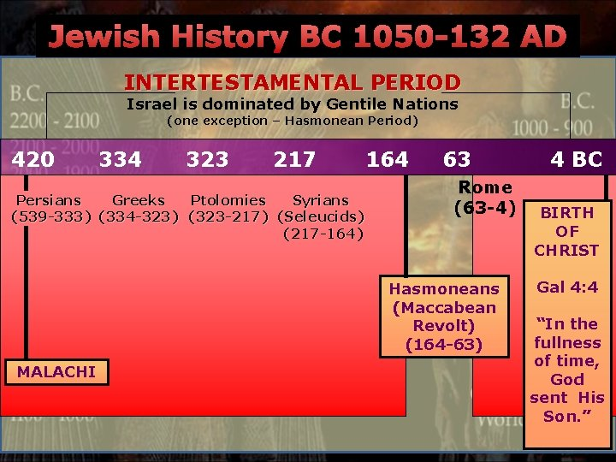
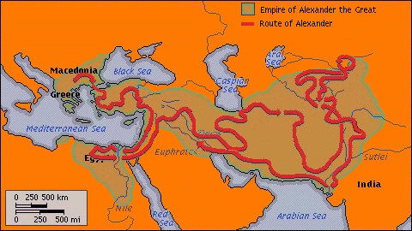
Hellenization
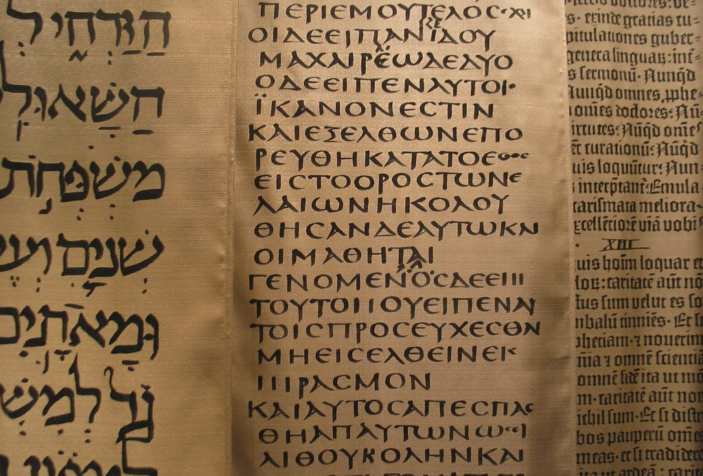
Septuagint

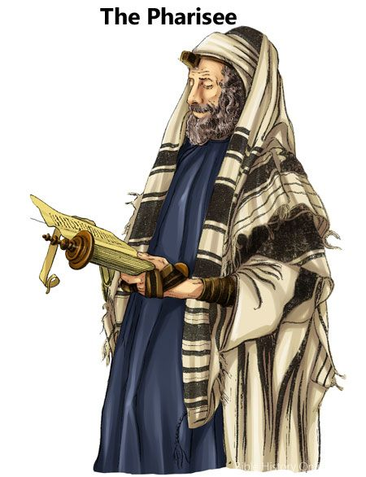
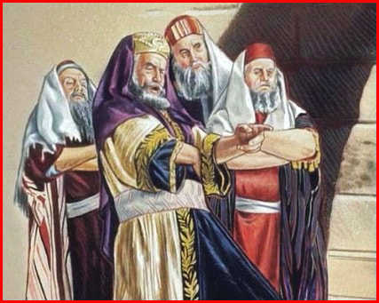
Sadducees

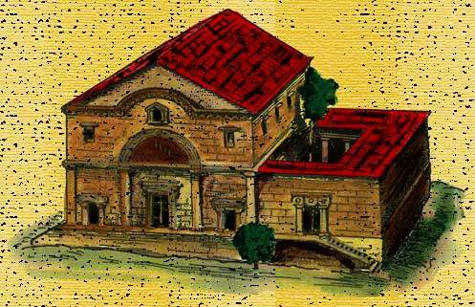
Synagogue
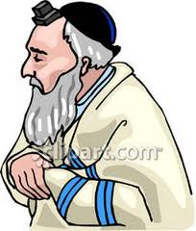
Rabbi

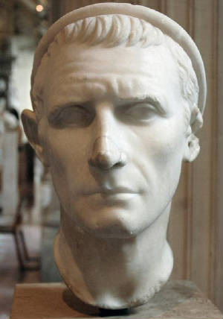
Antiochus Epiphanes
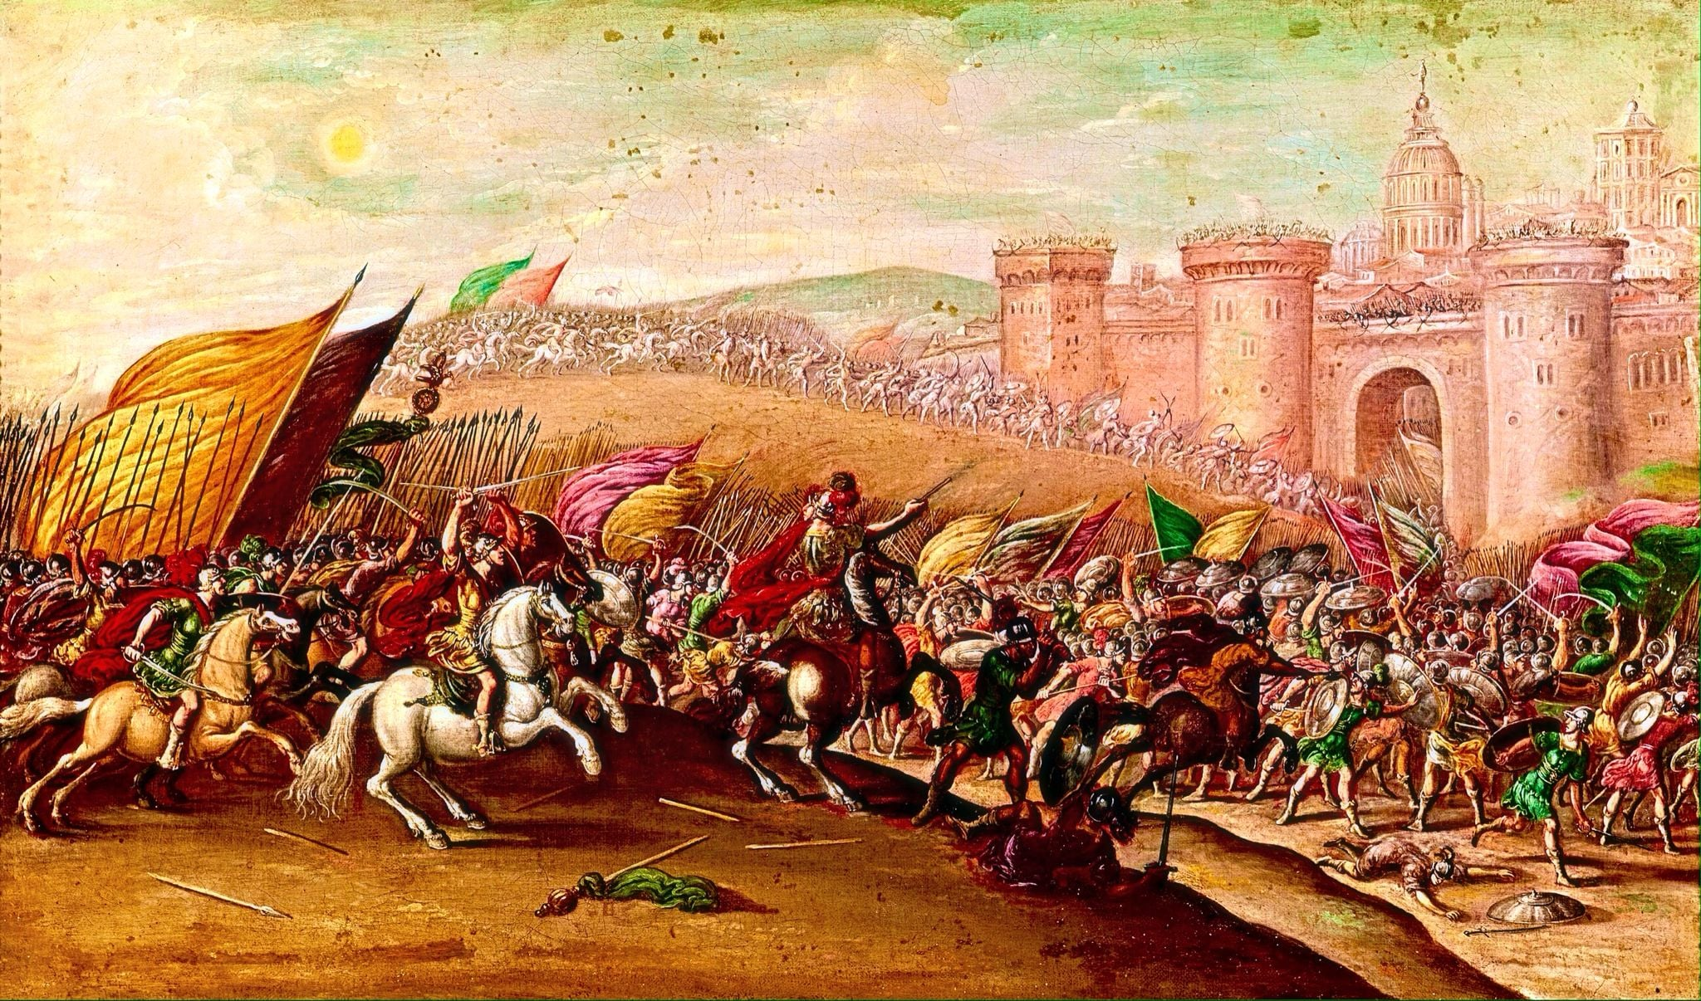
Maccabees
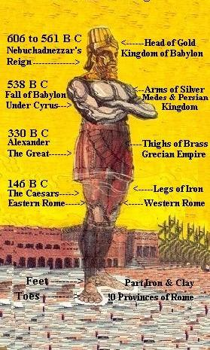
oneyearbibleblog.com
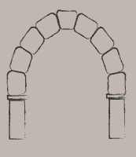
http://www2.ma.psu.edu/~ma_tapps/arch/roman.html

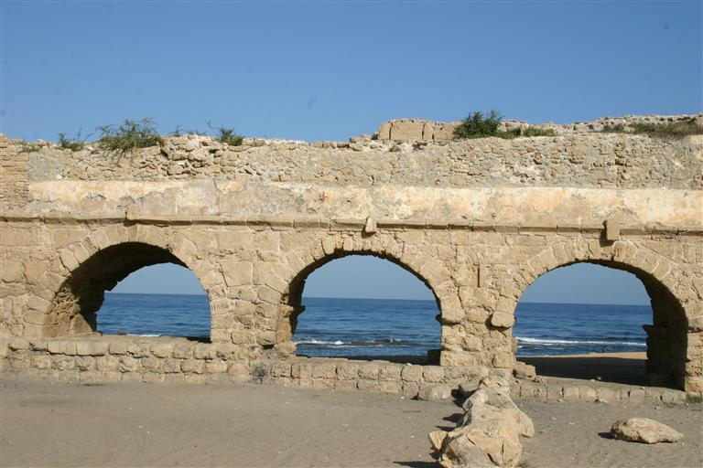
http://www2.ma.psu.edu/~ma_tapps/arch/roman.html
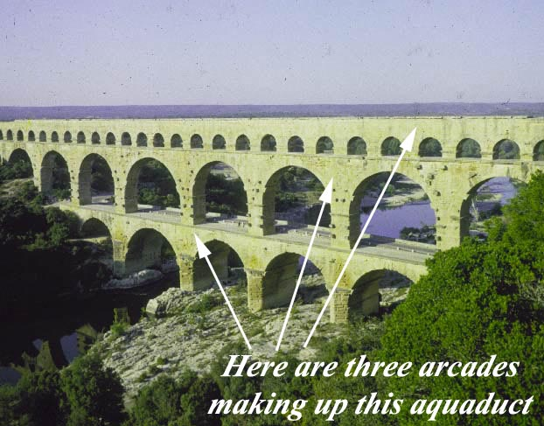
fitpacking.com
Built together, Roman Arches form an arcade.
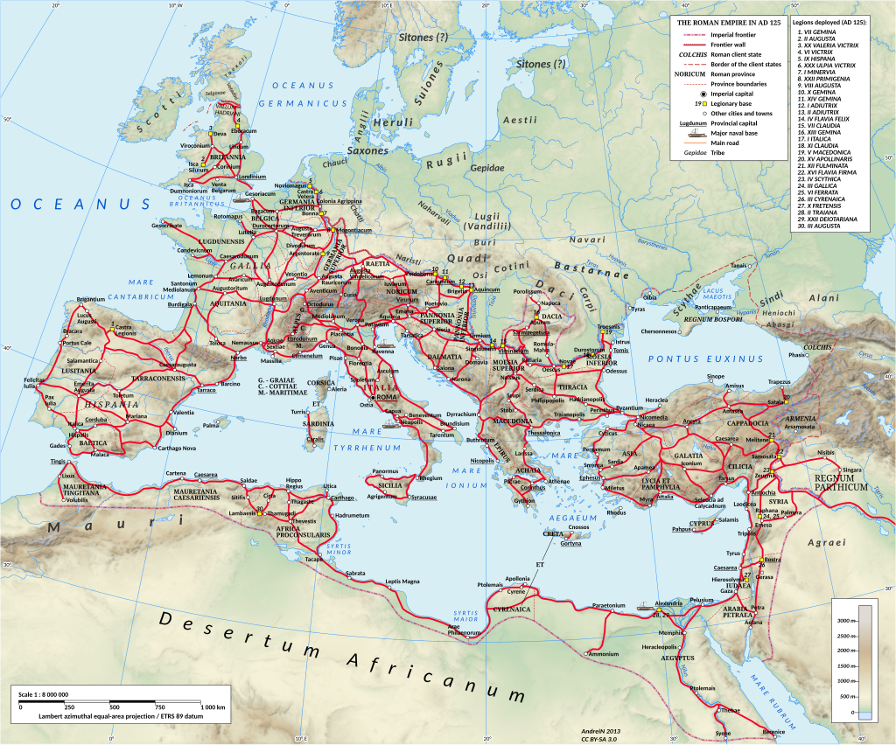
By DS28 - File:Roman Empire 125 general map.SVG, CC BY-SA 4.0, https://commons.wikimedia.org/w/index.php?curid=68002775

Roman Roads
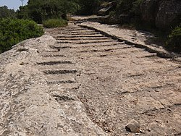
Roman roads - Wikipedia

An Old Roman Road from Jerusalem

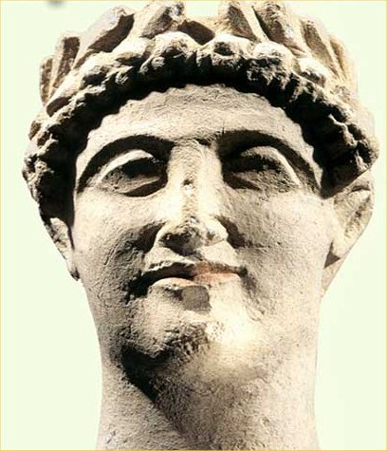
http://www.myclassiclyrics.com/artist_biographies/Herod_the_Great_Biography.htm
Herod the Great
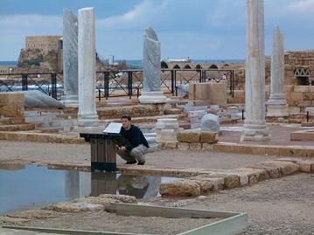
tiuli.com
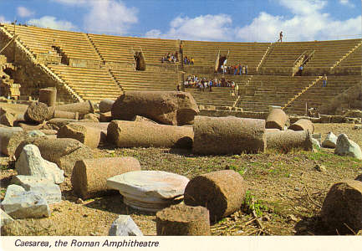
Ruins of Caesarea
from andreas-praefcke.de
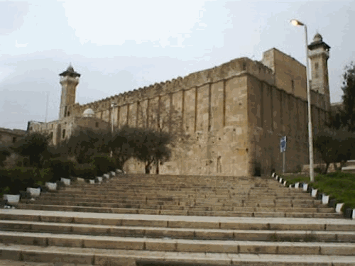
from jewishvirtuallibrary.org
The Tomb of the Patriarchs at Machpelah

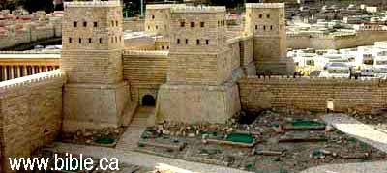
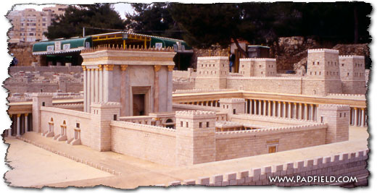
from http://www.bible.ca/archeology/bible-archeology-jerusalem-temple-mount-threshing-floor-fortress-of-antonia.htm
Model of the Antonia Fortress
from www.padfield.com
Model of the Temple with the Antonia
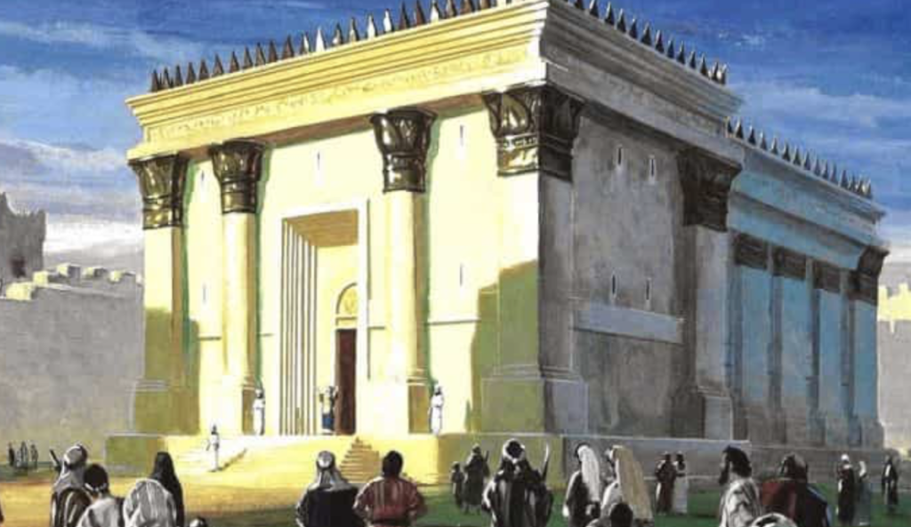

Screenshot-2019-04-08-at-18.32.41-1024x593.png (1024×593)

Artist’s rendition of Herod’s Temple
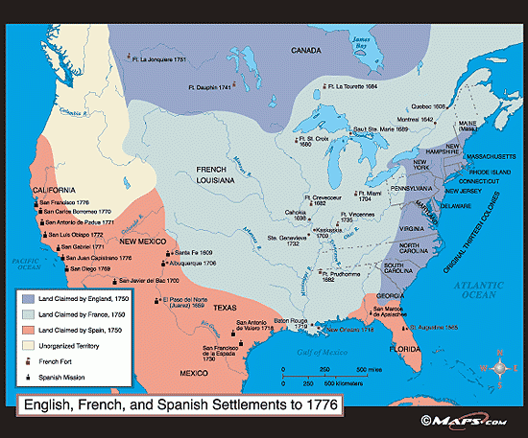
2-de-1776-la-fin-du-xixe-si-cle-17a7-jazz-soul-groove.gif (550×457)
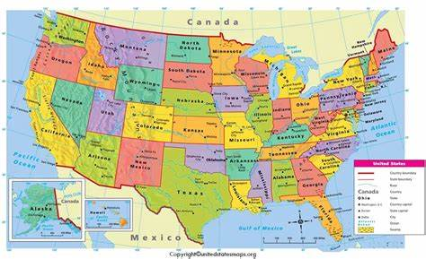
usa-political-map.jpg (900×550)
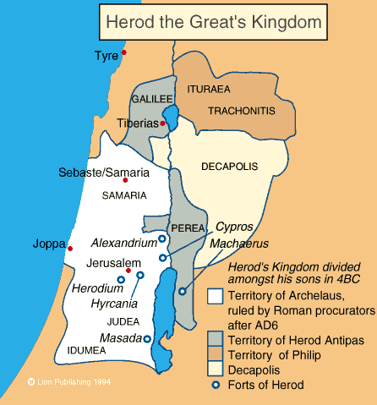
from http://www.painsley.org.uk/re/Atlas/herodpal.gif
Roman Numerals
I = 1
V = 5
X = 10
L = 50
C = 100
D = 500

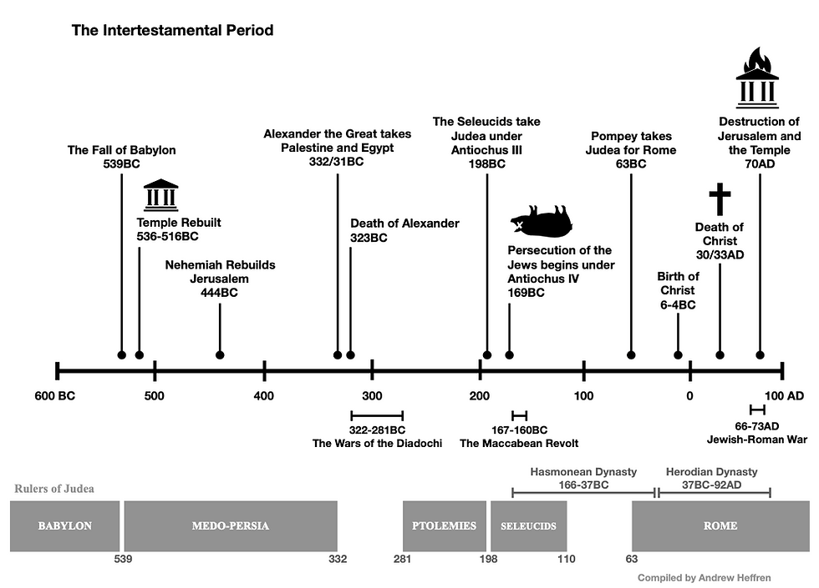 14a200_4d93042f88bf4b73ae204b107a0b41eb~mv2.png (980×705)
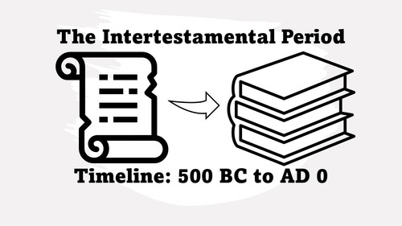
file.jpg (500×281) (altered)

