27.14a Intertestamental Period, Part A
✓ “Check” it out. An opinion, inference, supposed conversation, or fact one can verify follows.
[. . .] Brackets indicate a remark to the teacher that will not be read aloud; they also show answers to questions.
Visuals and Tools:
- Pictures and other visuals found at the end of this lesson. Check “Activities” and “Handwork” found below for additional needed materials. Please give credit to the sources of pictures.
- A piece of paper or cardboard to cover/reveal each section of Nebuchadnezzar’s image picture
- A time line
- A displayed printed copy of page 5 might help readers see the terms as they are taught. (They might also keep the teacher on track.)
- Two 15-minute videos to help the teacher are found at 15 | Bible Basics: Intertestamental Period Part 1 | Understand the Bible for New Believers15 | Bible Basics: Intertestamental Period Part 1 | Understand the Bible for New Believers and 16 | Bible Basics: Intertestamental World History | Understand the Bible for New Believers.
Bible Time Tips and Terms to Teach: Vocabulary words are enlarged for flashcards at the end of this lesson. Print on colorful cardstock and cut apart.
- empire: area and people that include more than one country controlled by a leader called an emperor. For example, King Nebuchadnezzar controlled a vast area from Babylon to Egypt; this area and the people living there were his empire.
- b.c. and a.d.: These are terms about the calendar. b.c. means the years “before Christ”; a.d. means “in the year of our Lord” (Latin Anno Domini) and includes the years from a.d. 1 to the present. Thus, for hundreds of years we determined a major division in our calendar based on the birth of Jesus Christ. However, avoiding ties to Christianity, the current trend is to use bce (Before Common Era) instead of b.c. and ce (Common Era) instead of a.d.¹
- Hellenization: (pronounced hell-en-eh-ZA-shun) the spread of the Greek culture and language. Hellenes was a term the ancient Greeks called themselves. As a result of Hellenization, Greek was the universal language spoken throughout the civilized world from 300 b.c. to a.d. 200—that’s 500 years, including the time of Christ.
Introduction/Review:
When we studied Daniel’s life, we learned that Nebuchadnezzar had dreams that foretold the future. One dream was of a great image that pictured coming worldwide empires. The head of gold represented Nebuchadnezzar and his Babylonian Empire. The chest and arms of silver were the Medo-Persian empire. Cyrus of this empire let the Jewish people leave Babylon and go back home. Esther, Zerubbabel, Ezra, and Nehemiah lived under this empire. We will come back to look at the rest of this image during our story.
Four hundred years is a long time. The people of Israel had been in Egypt about four hundred years before Moses brought them out of Egypt and to the Promised Land. A little more than four hundred years ago, the King James Version of the Bible was published. It’s the Bible translation your grandparents grew up with.
Also, about four hundred years ago, the United States was being populated by people who came from England and other European nations. The United States of America has been a nation only about 250 years—since 1776. So you can see four hundred years is a lo-o-ong time.
Story:
Intertestamental Period
After the last book of the Old Testament, Malachi, was written, four hundred years passed before Jesus was born and the New Testament was written. No word came from God, and no Scripture was written during this 400 years, so it is called “The 400 Silent Years” or “The Intertestamental Period” between the two main parts of our Bible, the Old and the New Testaments.
Many events took place during this period that greatly influence our understanding of the New Testament when God again inspired His Scripture. We will take two lessons to study this section of history, for history is really “His (Jesus’) story,” isn’t it?
Synagogues
In order to worship God and learn the Scriptures while they were in Babylon, Jews began meeting together at buildings called synagogues. These are somewhat like churches today in that they were places where people could pray, read Scripture together, and have the Scripture interpreted. Wherever at least ten Jewish men lived, there a synagogue could be established. Synagogues later became numerous in the Bible Land.
Rabbis
Ezra had gathered all the Old Testament books together into one whole. We can see by this chart [page 12] that Ezra arranged the Old Testament books differently from the way we do. The Hebrew Bible (of only the Old Testament) still has this arrangement—The Law, The Prophets, and The Writings.
Do you remember that scribes were men who copied the Scriptures and that copying was a long and intense process? Some scribes were known as lawyers (students of the law) and were rabbis, or teachers, in the synagogues.
The Talmud
During the Intertestamental Period some rabbis wrote down their interpretation of the Law. When these opinions were gathered together, the collection eventually² became known as the Talmud, or the Jewish writings. Like the Jews of the Intertestamental Period and Jesus’ day, Jews today place more importance on these writings than they do on God’s actual Old Testament.
Greek Empire
Let’s go back to Nebuchadnezzar’s image. The head of gold was Babylon; the chest and arms of silver were Medo-Persia. Even while Esther and Nehemiah lived, the empire represented in the belly of bronze was becoming powerful. Within another hundred years, in 331 b.c., that nation became an empire, the Greek empire. Alexander the Great became its leader.
Alexander began conquering the world at age twenty. In less than five years, he had completed his task, gaining even more territory than Nebuchadnezzar had gotten. He encouraged Jews to settle throughout his empire and establish many cities. In order to unify his whole empire, he spread the Greek culture and language. What is the term for the spread of Greek culture and language? [Hellenization.]
The Septuagint (pronounced sep-TOO-ah-jint)
An important event during this period, therefore, was the translation of the Old Testament from Hebrew into Greek. Why was this important? More people could understand the Scripture because it was written in a language everyone understood. Because the translation was completed by seventy scholars,³ this translation has a name meaning “seventy”—Septuagint.
Sadducees
A group of Jews called the Sadducees organized themselves during this time. They were educated men whom the Greeks placed in leadership over the people. However, their belief in the Scriptures was not so great. In fact, they did not believe in a resurrection—that we will be raised from the dead to be judged by God. That is why they were “sad, you see.”
Ptolemies (pronounced TALL-eh-meez)
Since Alexander had no son to continue the leadership of his empire when he died, his empire was divided among his four army generals. Two of these generals, Ptolemy and Seleucus, were important to Israel. At first, the Ptolemies (Ptolemy and his descendants) ruled over Israel and Egypt, allowing the Jews freedom to worship God.
Seleucids (pronounced seh-LOO-sids)
After about one hundred years (in 198 b.c.), however, the Seleucids won control of Israel. They were more interested in Hellenization than the Ptolemies and did not allow religious freedom.
Pharisees
Not being able to worship God as He had directed was a good reason for some Jews to resist Hellenization and to lead people back to Jewish culture and the Old Testament law of God. These reformers were called Pharisees. Originally, they were godly, but as years passed, they became self-righteous, thinking and acting as if they were better than others because of the “godly” things they did.
Antiochus Epiphanes (pronounced an-TIE-o-kiss ee-PIFF-en-eez)
A Seleucid king, Antiochus Epiphanes, outlawed worship of the one, true God and demanded worship of Greek gods. Are Greeks gods the one, true God? No, they are many false gods. So instead of referring to the one true God as Jehovah, Antiochus forced the people to identify their god as Zeus (or Jupiter), the chief Greek god. In fact, Antiochus went so far as to dedicate God’s Temple in Jerusalem to Zeus. He outlawed the Sabbath and used the Temple as a place to commit terrible sins. In mockery of our God’s law, he offered unclean animals—pigs—on the altar of the Temple! Daniel 11:31 had prophesied about this man, having called him the “abomination of desolation”—a horrible abomination that destroys.
The Maccabbees
This terrible blasphemy of God infuriated an old Jewish priest named Mattathias Macabee, who refused to offer sacrifices on a pagan altar to a false god. Instead, he and his sons organized an effective rebellion against the Seleucids. Exactly three years after the first pig sacrifice in the Temple, the Maccabbees cleansed the Temple of all pagan symbols and took control of Jerusalem, ruling about 80 years and encouraging godliness and the keeping of the law of Moses. This brings our time line date clear down to 63 b.c.
The Apocrypha (pronounced ah-POCK-rih-fah)
I want to tell you about one more thing—the books of the Apocrypha, spiritual books written during the Intertestamental Period. Some Bibles, e.g., Roman Catholic Bibles, include these books between the Old and New Testaments of their Bibles. We do have them in our Bibles because we do not believe they were inspired by the Holy Spirit. Some of these books are actually fairy tales. Others, like Maccabees, are history and valuable information about the Maccabean period.
There. You see, in one lesson we’ve told you a little about events that spanned almost 350 years. Next week we’ll finish this four-hundred-year intertestamental period. Then we can go on to study the life of Christ—the best part of the Bible!

¹To be technical, b.c. appears after the year (568 b.c.), but a.d. appears before the year (a.d. 70).
²Around the year a.d. 200
³Actually, seventy-two
Lessons from this lesson:
- We see Jesus:
This long period of time prepared the way for the life of Jesus Christ. The people and things we’ve talked about—Pharisees, Sadducees, synagogues, rabbis, scribes, lawyers, Septuagint, interpretations of God’s law—were put in place and were ready for the coming Christ, the Messiah.
- Just as in the Maccabbee Revolt, when religious freedoms are taken away, God will often raise up people to recover those freedoms.
- Synagogues were places of worship. Just as Jews met in synagogues, we need to meet to worship, pray, and learn God’s Word in our churches as well as at home.
- Nebuchadnezzar’s image was use by God to prophesy the various empires that would arise in the world. They came about just as God had said. We can trust God’s Word.
Activities:
- Play dough: phylactery [seen on the forehead in the picture of the rabbi on page 13 below]; sword
- Snack: Grape Time Line. String 8 grapes on a skewer for each student. As the students remove each grape, have them review one of the seven parts of the time line [see page 10] as per the review questions game.
- Look at the extra charts at the end of this lesson for further review of the period.
- Watch a secular video of almost 9 minutes: The Hellenistic Period - Ancient World History for Kids! Suggestion: preview the video.
- Review questions: (Game: Print and back with paper towel, or print on cardstock, the Intertestamental time line found on page 10 below. Cut the title section from the rest of the chart and then cut the chart itself apart between the dates; keep the pieces in chronological order. A student who answers a question correctly, after reading aloud the information for that date, may place one piece of the time line on a flannel board or into a pocket chart. The eighth person to answer correctly may place the titles on the board or in the pocket chart.)
- What does b.c. mean? [Before Christ.]
- True or false: An empire is just one country and its citizens. [False; several countries.]
- Fill in the blank. Hellenization is the spread of ___________ culture. [Greek.]
- Fill in two blanks. The Septuagint was a translation of the ______ _____________ from Hebrew into Greek. [Old Testament.]
- What was the general name of the religious leaders of the people? Because they didn’t believe in the resurrection, a little phrase describes how they should have felt. That phrase helps us remember their name. [“Sad you see”; Sadducees.]
- Fill in the blank. The teachers of God’s law were called ___________. [Rabbis; also accept scribes, lawyers, Pharisees.]
- The Seleucids had made God’s Temple a temple to Zeus/Jupiter. Why did the Maccabbees fight against the Seleucids? [To get the worship of God and their country back; accept similar answers.]
- How many years did the Intertestamental Period last? [400.]
Memory Verse[s]:
- Hebrews 4:12: “The word of God is living and powerful, and sharper than any two-edged sword, piercing even to the division of soul and spirit, and of joints and marrow, and is a discerner of the thoughts and intents of the heart.” [This may be shortened to only the first clause.]
Handwork:
- Print page 27 found below for each student. Students will draw a line from each of the four pictures to the place it is listed on the chart.
empire
b.c./a.d.
Hellenization
Intertestamental Period
synagogues
rabbis
Talmud
Greek Empire
Septuagint
Sadducees
Ptolemies
Seleucids
Pharisees
Antiochus Epiphanes
Maccabees
Apochrypha
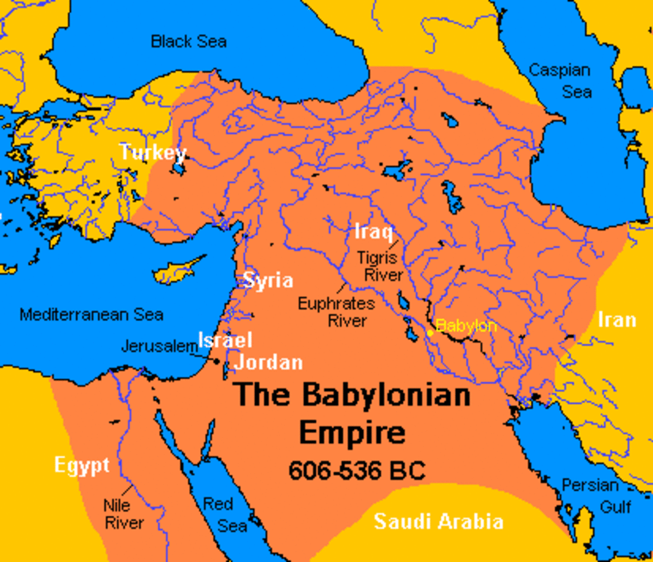

E
M
P
I
R
E
babylonian empire - Search Images
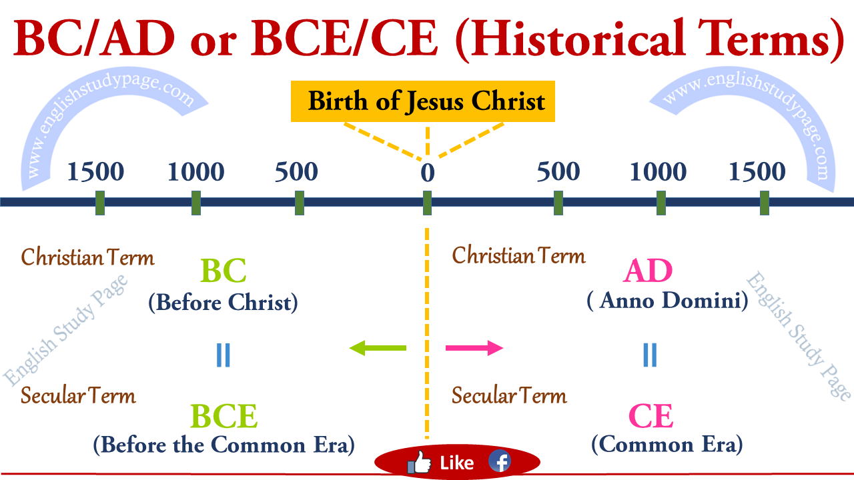
b.c. and a.d. - Search Images
seeking4truth.com
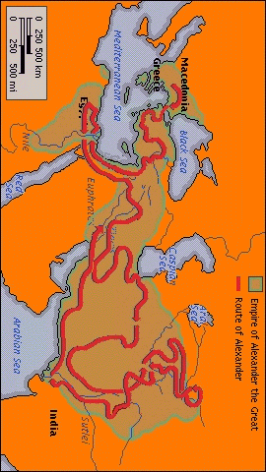
Hellenization
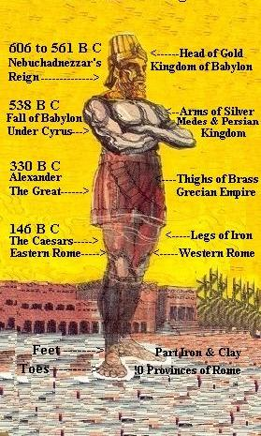
oneyearbibleblog.com
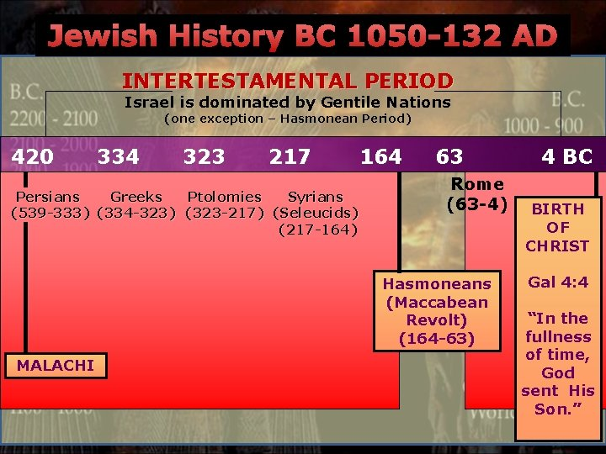
the intertestamental period timeline - Search Images
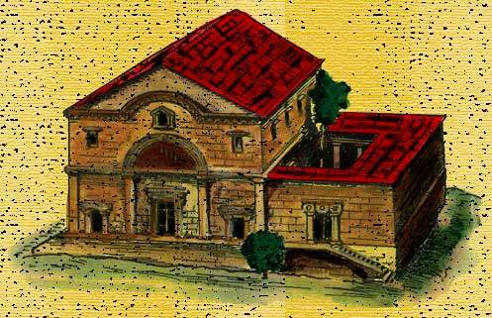
New Testament Synagogue
synagogue-capernaum.jpg (497×321)
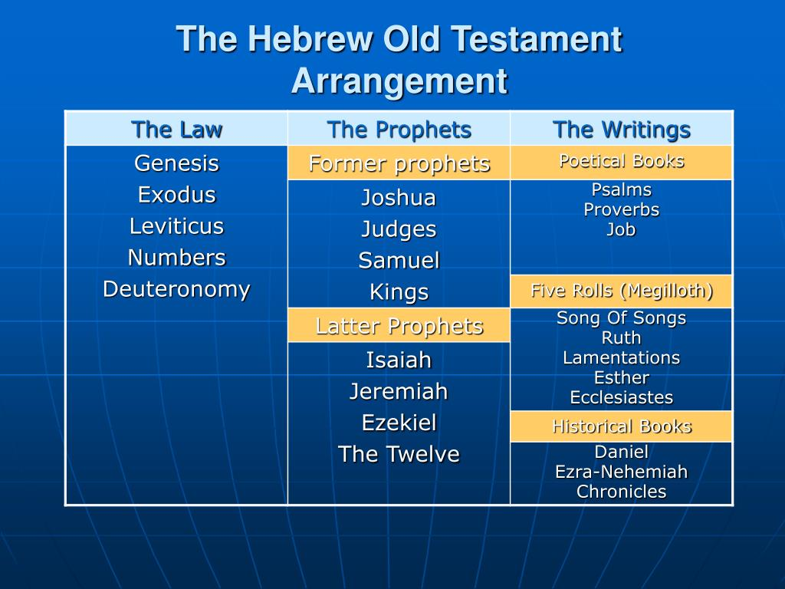
the-hebrew-old-testament-arrangement-l.jpg (1024×768)
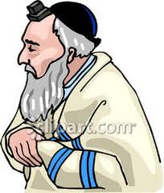
(Clipart Panda - Free Clipart Images)

Rabbi
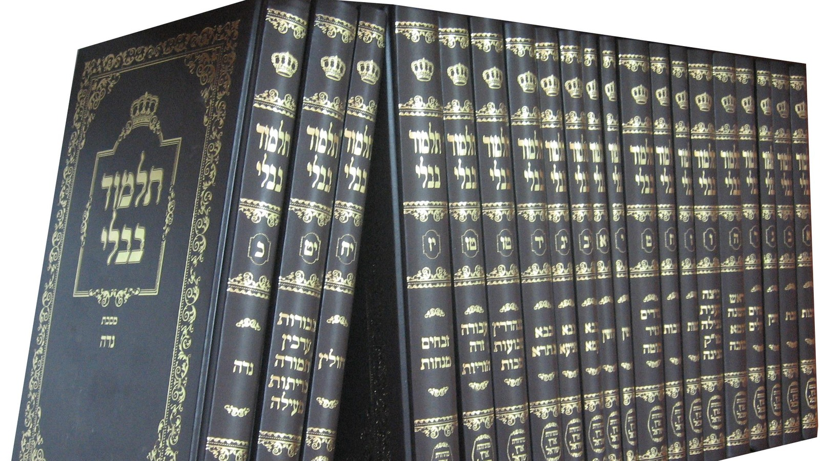
The Talmud
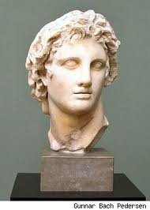
culturewave.es
l-intro-1659537622.jpg (1600×900)

Alexander the Great
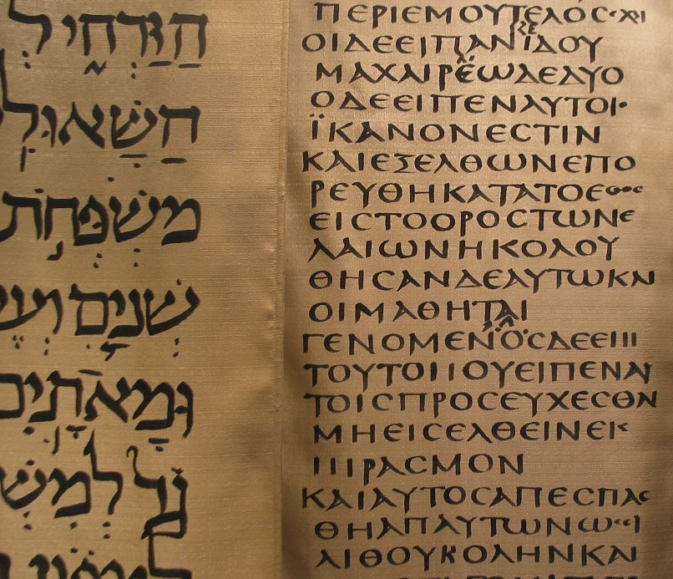
Hebrew-Greek-Maniscript-1024x693.jpg (1024×693)
(Hebrew) (Greek)
Septuagint
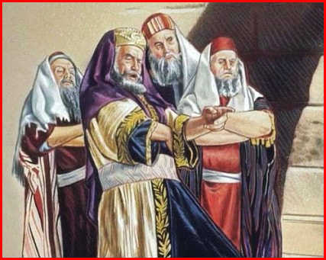
Sadducees (sad you see)
sadducees-13a_orig.jpg (427×341)
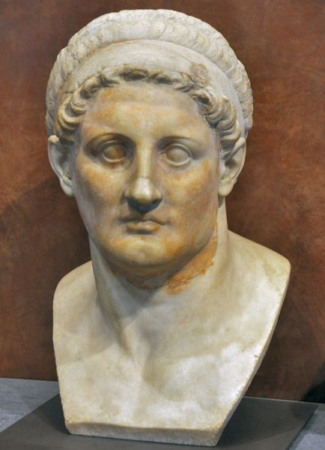
(livius.org)
Ptolemy I
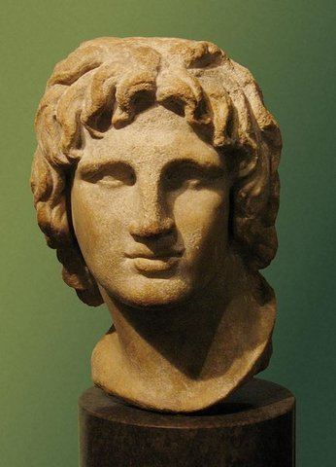
(Seleucus I Nicator - Alchetron, The Free Social Encyclopedia)
Seleucus I
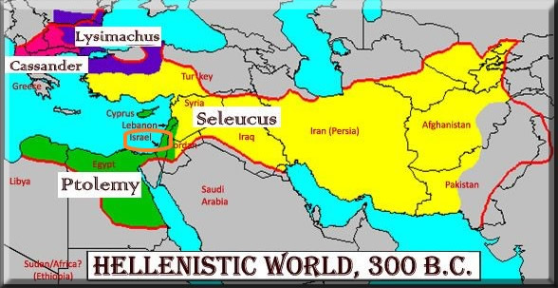
Greek-4-rulers2.jpg (588×303)

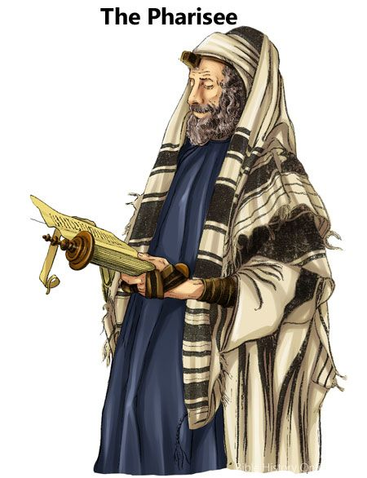
b7ee48d2a3881ccf1fc89cc3b5713284.jpg (450×586)
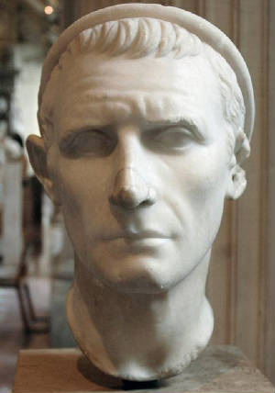
(tenhorns.com)
Antiochus Epiphanes
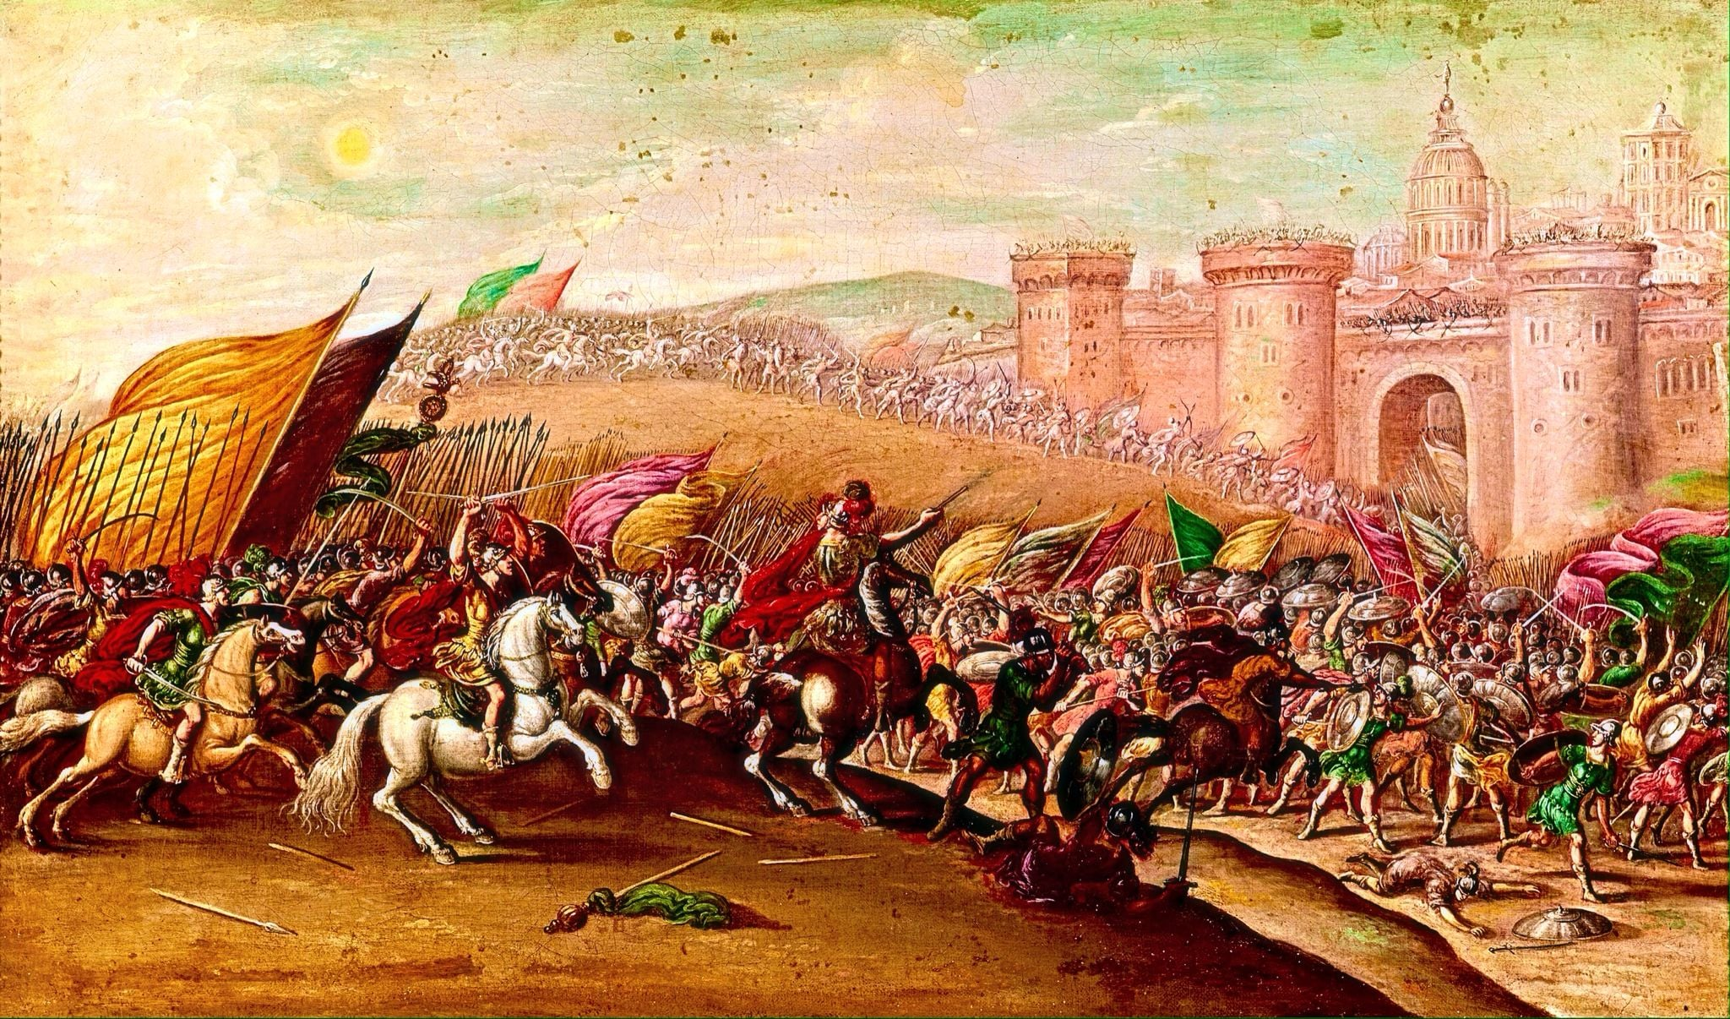
Maccabee Rebellion
(1 Maccabees 5: Fight for your kindred! : r/SacredBible)
c95786ffec6a9cb1291d843495022457.jpg (3300×2550)
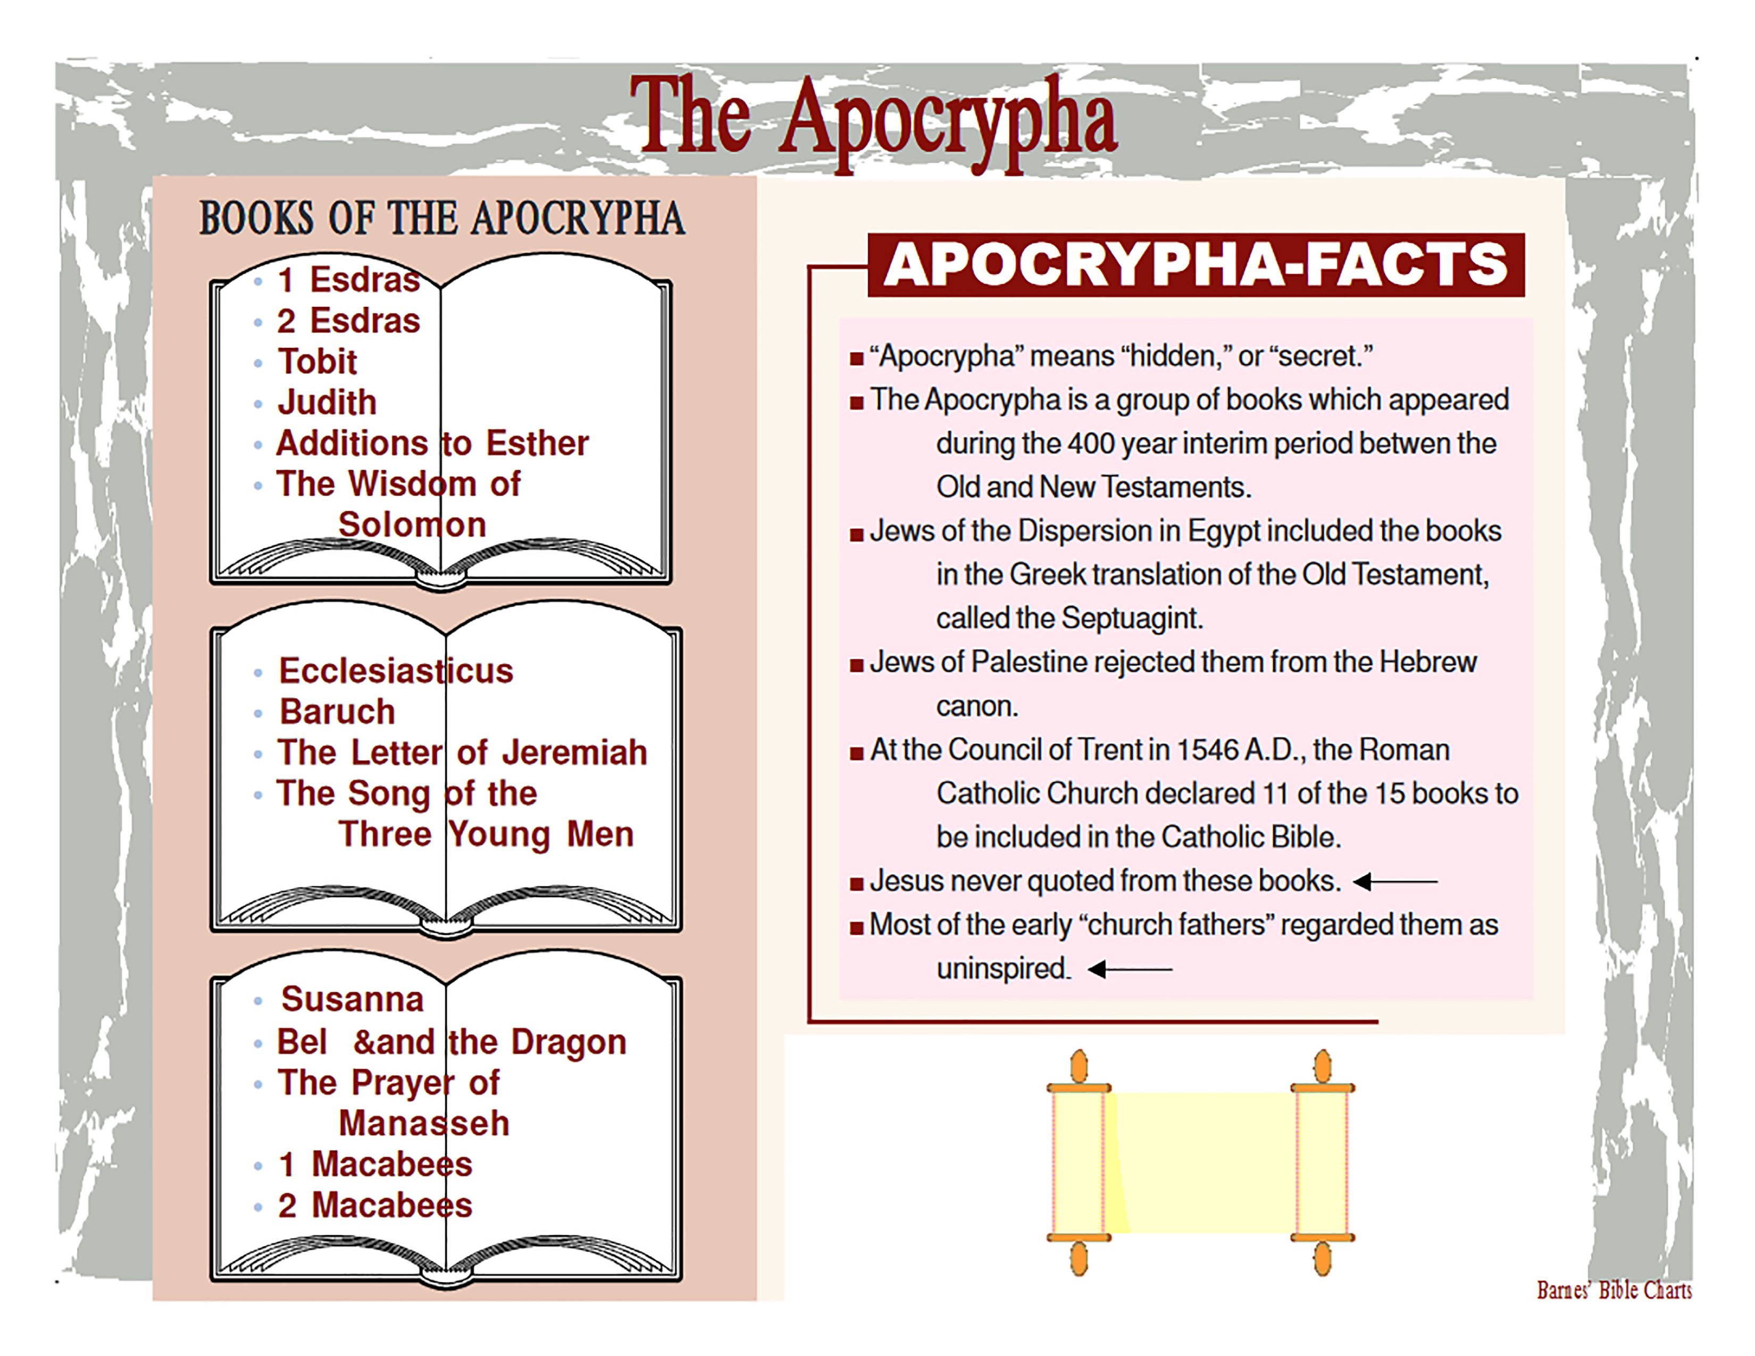
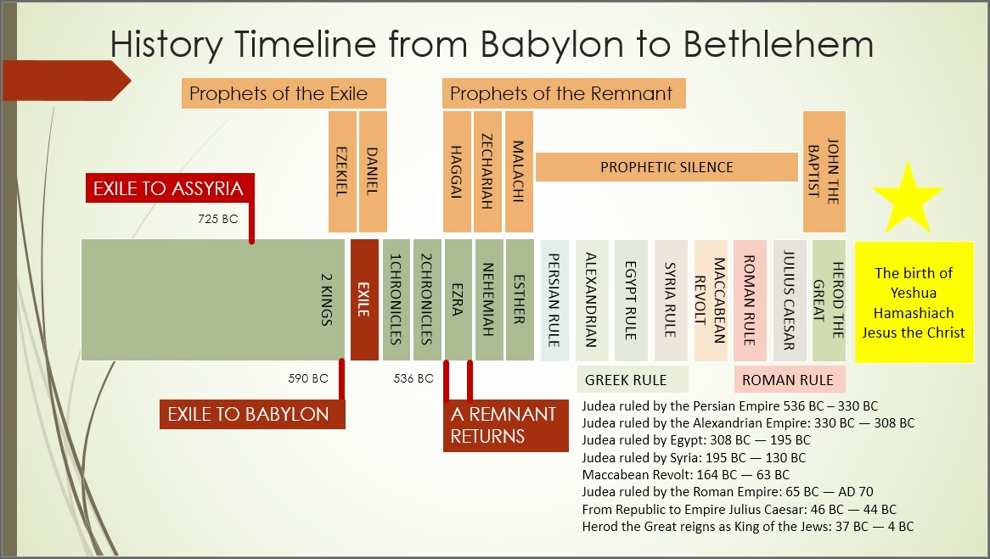
An overview of the Old Testament: Part 4 – Mountjoy Bible School

THE INTERTESTAMENTAL PERIOD 400 Years Of Gods Silence

400 Silent Years
Intertestamental Period
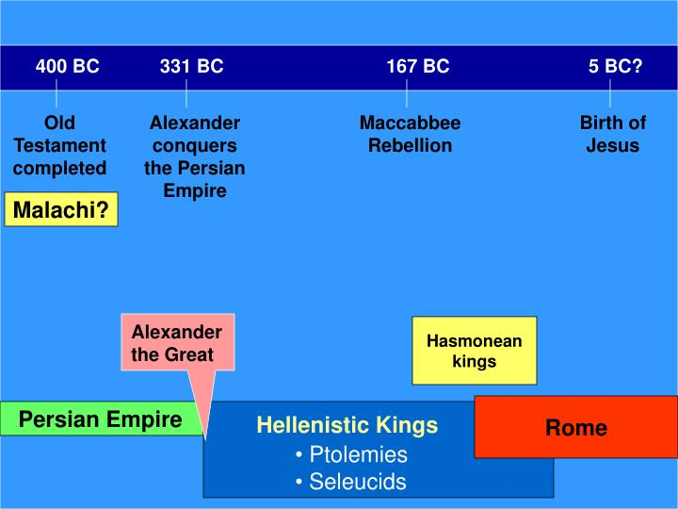
slide15-n.jpg (720×540)
Maccabbee Rebellion
Alexander
Ptolemy I
Seleucus

Draw a line from each picture to the place it belongs on the chart.

